A Project Report on

## Title of your project

Submitted in partial fulfillment of the requirements for the award of the degree of

### Bachelor of Engineering

in

### Branch Name

by

### Name of the Student1(Student ID) Name of the Student2(Student ID) Name of the Student3(Student ID) Name of the Student4(Student ID)

Under the Guidance of

### Name of Guide Name of Co-Guide



#### Department of Branch Name

A.P. Shah Institute of Technology G.B.Road,Kasarvadavli, Thane(W), Mumbai-400615

UNIVERSITY OF MUMBAI

#### Academic Year 2017-2018

This Project Report entitled ***“Project Title”*** Submitted by ***“Name of the Stu- dent1”(Student ID),“Name of the Student2”(Student ID),“Name of the Stu- dent3”(Student ID),“Name of the Student4”(Student ID)***is approved for the par- tial fulfillment of the requirenment for the award of the degree of ***Bachelor of Engineering*** in ***Branch Name*** from ***University of Mumbai*** .

(Name) (Name)

Co-Guide Guide

Prof. Kiran Deshpande

Head Department of Information Technology

Place:A.P.Shah Institute of Technology, Thane Date:

This is to certify that the project entitled ***“Title of project”*** submitted by ***“Name of student1” (Student ID),“Name of student2” (Student ID),“Name of stu- dent3” (Student ID),“Name of student4” (Student ID)*** for the partial fulfillment of the requirement for award of a degree ***Bachelor of Engineering*** in ***Branch Name.***,to the University of Mumbai,is a bonafide work carried out during academic year 2017-2018.

(Name) (Name)

Co-Guide Guide

Prof. Kiran Deshpande Dr. Uttam D.Kolekar Head Department of Information Technology Principal

External Examiner(s) 1.

2.

Place:A.P.Shah Institute of Technology, Thane Date:

We declare that this written submission represents our ideas in our own words and where others’ ideas or words have been included, We have adequately cited and referenced the orig- inal sources. We also declare that We have adhered to all principles of academic honesty and integrity and have not misrepresented or fabricated or falsified any idea/data/fact/source in our submission. We understand that any violation of the above will be cause for disciplinary action by the Institute and can also evoke penal action from the sources which have thus not been properly cited or from whom proper permission has not been taken when needed.

———————————————

(Signature)

———————————————

(Name of Student1 and Student ID) (Name of Student2 and Student ID) (Name of Student3 and Student ID) (Name of Student4 and Student ID)

Date:

#### Abstract

abstract in 10 to 15 lines.

1. Introduction 1

1.1 Section . . . . . . . . . . . . . . . . . . . . . . . . . . . . . . . . . . . . . . . 1

1.1.1 Subsection . . . . . . . . . . . . . . . . . . . . . . . . . . . . . . . . . 1

1.1.2 Use of Bullets . . . . . . . . . . . . . . . . . . . . . . . . . . . . . . . 2

1.1.3 Use of Tables . . . . . . . . . . . . . . . . . . . . . . . . . . . . . . . 2

1. Literature Review 3
2. Chapter 3 4
3. Chapter 4 5
4. Result 6
5. Conclusions and Future Scope 7

Bibliography 8

Appendices 9

Appendix-A . . . . . . . . . . . . . . . . . . . . . . . . . . . . . . . . . . . . . . . 9

Publication 12

1.1 Intrusion Detection System . . . . . . . . . . . . . . . . . . . . . . . . . . . 1

1.1 An Example of a Table . . . . . . . . . . . . . . . . . . . . . . . . . . . . . . 2

5.1 Wormhole Attack Comparison with AODV Protocol . . . . . . . . . . . . . . 6

# List of Abbreviations

IDS: Intrusion Detection System

WSN: Wireless Sensor Network MANET: Mobile Ad-Hoc Network

AODV: Ad-Hoc On-demand Distance Vector Routing DSR: Dynamic Source Routing Protocol

NS2: Network Simulator 2

ACK: Acknowledgement

AGT: Agent

RTR: Router

# Chapter 1 Introduction

The title of Chapter 1 shall be Introduction. It shall justify and highlight the problem posed, define the topic and explain the aim and scope of the work presented in the report. It may also highlight the significant contributions from the investigation.

## Section

You can also create section and subsection

A chapter can be divided into Sections, Sub-sections and Sub-sub Sections so as to present different concepts separately.

### Subsection

Sections and sub-sections can be numbered using decimal points, e.g. 2.2 for the second section in Chapter 2 and 2.3.4 for the fourth Sub-section in third Section of Chapter 2.

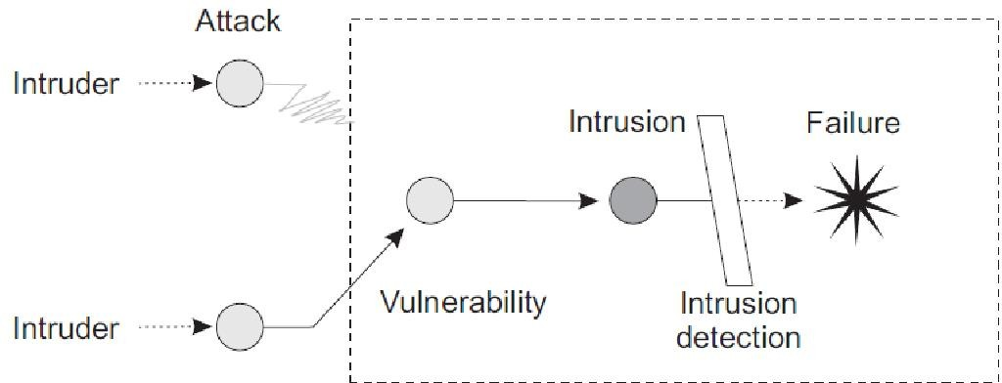

Figure 1.1: Intrusion Detection System

#### Host-based IDS and

1. **Network-based IDS.**
2. **Specification based Intrusion Detection.**
   * 1. **Use of Bullets**

ˆ item 1

ˆ item2

ˆ item3

ˆ item4

### Use of Tables

|  |  |
| --- | --- |
| One | Two |
| Three | Four |

Table 1.1: An Example of a Table

# Literature Review

This shall normally form Chapter 2 and shall present a critical appraisal of the previous work published in the literature pertaining to the topic of the investigation. emphasis of the chapter shall depend on the nature of the investigation.

# Chapter 3

Add your chapter Name

# Chapter 4

Add your chapter Name

# Result

This shall form the penultimate chapter of the report and shall include a thorough evaluation of the investigation carried out and bring out the contributions from the study. The discus- sion shall logically lead to inferences and conclusions as well as scope for possible further future work.

|  |  |  |
| --- | --- | --- |
| **Parameters** | **Wormhole Attack** | **AODV** |
| Total No.of Sent Packets | 85068 | 85068 |
| Total No.of Received Packets | 16252 | 68068 |
| Total No.of Drop Packets | 61948 | 16864 |
| Throughput | 98.01 | 410.24 |
| Delay | 0.0244 | 0.1528 |
| Jitter | 23.93 | 100.16 |

Table 5.1: Wormhole Attack Comparison with AODV Protocol

# Conclusions and Future Scope

This will be the final chapter of the report. A brief report of the work carried out shall form the first part of the Chapter. Conclusions derived from the logical analysis presented in the Results and Discussions Chapter shall be presented and clearly enumerated, each point stated separately. Scope for future work should be stated lucidly in the last part of the chapter.

1. Abror Abduvaliyev, Al-Sakib Khan Pathan, Jianying Zhou, Rodrigo Roman and Wai- Choong Wong ,“On the vital Areas of Intrusion Detection Systems in Wireless Sensor networks”,IEEE Communications Surveys & Tutorials, Accepted For Publications, 2013- in press.
2. H.H. Soliman, et al,“A comparative performance evaluation of intrusion detection tech- niques for hierarchical wireless sensor networks”, Egyptian Informatics Journal (2012) 13, 225238.
3. Giannetsos Athanasios, “Intrusion Detection in Wireless Sensor Networks”, Master THE- SIS, Carnegie Mellon University, April 8, 2008.
4. K.Fall and K.Varadhan,“The NS Manual”, <http://www.isi.edu/nsnam/ns/doc/ns>doc.pdf., 1 Feb 2014.
5. Jae Chung and Mark Claypool,“NS by Example-Tutorial”,<http://nile.wpi.edu/NS/overview.html>, 1 Feb 2014.
6. Network Simulator blog, [http://Mohittahilani.blogspot.com](http://Mohittahilani.blogspot.com/) , 1 Feb 2014.
7. AWK Script for NS2, <http://mohit.ueuo.com/AWK-Scripts.html>, 1 Feb 2014.

Detailed information, lengthy derivations, raw experimental observations etc. are to be presented in the separate appendices, which shall be numbered in Roman Capitals (e.g. Appendix I). Since reference can be drawn to published/unpublished literature in the ap- pendices these should precede the Literature Cited section.

## Appendix-A: NS2 Download and Installation

1. Download ns-allinone-2.35.tar.gz from <http://sourceforge.net/projects/nsnam/>
2. Place ns-allinone-2.35.tar in your desired directory; like /home/vishal.
3. Go to terminal and do as following commands

#### sudo apt-get update

**sudo apt-get install automake autoconf libxmu-dev build-essential**

1. Extract ns-allinone-2.35 and after extracting go to folder ns-allinone-2.35 from Termi- nal as

#### $cd ns-allinone-2.35

$**./install**

1. Path Setting

#### $ gedit .bashrc

This command will open an existing file in editor. Just put the following path which is given bellow. [Remember that our ns-allinone path is /home/vishal. we will change this path according to our ns-allinone folder’s path]

export PATH=$PATH:/home/vishal/ns-allinone-2.35/bin:/home/vishal/ns-allinone-2.35/tcl8.5.10/ unix/home/vishal/ns-allinone-2.35/tk8.5.10/unix

export LD LIBRARY PATH=$LD LIBRARY PATH:/home/vishal/ns-allinone- 2.35/otcl-1.14:/home/ vishal/ns-allinone-2.35/lib

export TCL LIRARY PATH=$TCL LIBRARY PATH:/home/vishal/ns-allinone-2.35/tcl8.5.10/library

After this save and exit.

1. Now type in terminal to check that, is all command we entered in .bashrc is correct or not? And To take the effect immediately

#### $source .bashrc

1. Then perform the validation test using this command.

#### $ ./validate

1. Run ns2 using this command

$**ns**

We will get % prompt in our terminal. Now ns2 has been installed.

**Acknowledgement**

We have great pleasure in presenting the report on **Project Title.** We take this opportu- nity to express our sincere thanks towards our guide **Guide Name** & Co-Guide **Co-Guide Name** Department of IT, APSIT thane for providing the technical guidelines and sugges- tions regarding line of work. We would like to express our gratitude towards his constant encouragement, support and guidance through the development of project.

We thank **Prof. Kiran B. Deshpande** Head of Department,IT, APSIT for his encour- agement during progress meeting and providing guidelines to write this report.

We thank **Prof. Vishal S. Badgujar** BE project co-ordinator, Department of IT, APSIT for being encouraging throughout the course and for guidance.

We also thank the entire staff of APSIT for their invaluable help rendered during the course of this work. We wish to express our deep gratitude towards all our colleagues of APSIT for their encouragement.

#### Student Name1:

**Student ID1:**

**Student Name2:**

**Student ID2:**

**Student Name3:**

**Student ID3:**

**Student Name4:**

**Student ID4:**

# Publication

Paper entitled **“Paper Title”** is presented at **“International Conference/Journal Name”**

#### by “Author Name”.

12